PHONE CONTROLLED T.V. SYSTEM USING FPGA

Amit [Yadav - 16110011-](mailto:YADAV-16110011-amit.y@iitgn.ac.in) [amit.y@iitgn.ac.in](mailto:amit.y@iitgn.ac.in) | Ayush [Garg-161100261-](mailto:Garg-161100261-ayush.garg@iitgn.ac.in) [ayush.garg@iitgn.ac.in](mailto:ayush.garg@iitgn.ac.in)

Jatin Dholakia -16110066 - [jatin.dholakia@iitgn.ac.in](mailto:jatin.dholakia@iitgn.ac.in) | Rohit Sharma - 16110141 - [rohit.sharma@iitgn.ac.in](mailto:rohit.sharma@iitgn.ac.in)

**Abstract**  : We want to make mobile controlled T.V. system using FPGA and to integrate a TV remote into our phone infrared (IR) light sends digitally-coded pulses of infrared radiation to control functions such as power, volume, channels, playback or other features varying from device to device when the user presses a button on the handset.The infrared light pulses form a pattern unique to that button. The receiver in the device recognizes the pattern and causes the device to respond accordingly.A TV remote flashes the **IR LED on/off at the rate of 38 kHz** for certain periods of time with periods of off-time in between

It makes a different flashing pattern for each key on the remote.Different manufacturers of infrared remote controls use different protocols to transmit the infrared commands.The FPGA had inbuilt RS232 standards for serial communication, but in our project we used I/O pins of FPGA and made an FSM to fetch data from HC-05 Bluetooth module,

We read different algorithms and finally we implemented NEC protocol on the LG TV in our hostel area which follows NEC protocol.We used Bluetooth Module (HC 05) as Receiver and divided its frequency to reach a specified frequency of TV which reads ASCII value of each bit as serial input reading each bit by shifting followed by writing and storing in a 8-bit register.Thereafter converting each key of remote to the output according to the command bit which should be given to IR LED attached on FPGA according to the protocol followed by respected T.V.

If the IR LED blinks in the exact manner as expected by TV then we have our required result

***Index Terms*—** BLUETOOTH COMMUNICATION , FPGA (VERILOG) , NEC PROTOCOL , SERIAL COMMUNICATION

# **INTRODUCTION**[1]

Different TV follows different kinds of protocols and L.G T.V follows NEC protocol to make mobile controlled T.V. system using FPGA and to integrate a TV remote into our phone we used IR LED for giving signal to the receiver of TV similar to TV remote infrared (IR) light sends digitally-coded pulses of infrared radiation to control functions such as power, volume, channels, playback or other features varying from device to device when the user presses a button on the handset.The infrared light pulses form a pattern {which is to be decoded from NEC protocol} unique to that button. The receiver in the device recognizes the pattern and causes the device to respond accordingly.

# **PROCEDURES FOR PAPER SUBMISSION**

1. We used bluetooth communication to read incoming data from phone. It reads incoming bits serially at 9600 bits/second.
2. When a start bit is received, the FSM changes its state and starts to read the next 8 bits.
3. The 8 bits are stored in a register, which forms an ASCII character.
4. After the stop bit is received, the FSM enters its RESET state and waits for another start bit.
5. The 8 bits are then given as output to the 8 onboard LEDs.
6. A clock of 38 KHz of 25% duty cycle is made to send the signal to the TV through IR communication. Duty cycle is the ratio of (duration of logical ‘1’)/(duration of total cycle)*100% .It has 25% duty cycle to minimise power consumption.
7. Whenever, a change is detected in the 8 bits stored earlier, a 9ms pulse burst is sent followed by a 4.5ms space. This serves as the starting pulse for the NEC protocol.
8. This is followed by 8-bit address and logical inverse of it. Logical 1 is depicted by 1.12ms of pulse burst and 562 $μ$ s of space. Logical 0 is represented by 562 $μ$ s and 562 $μ$ s space.
9. This is followed by 8 bits command and 8 bits of command inverse.
10. This is followed by 562 $μ$ s pulse burst as a stop signal.

# **RESULTS AND DISCUSSIONS**

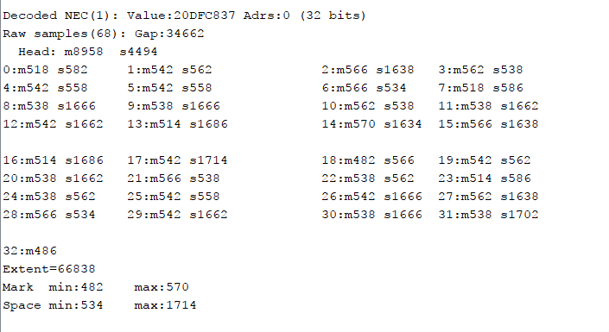

This diagram is expected output that we observed from arduino using LG TV remote

Here s stands for space or 0 in the output from LED and m stands for mark or a clock cycle

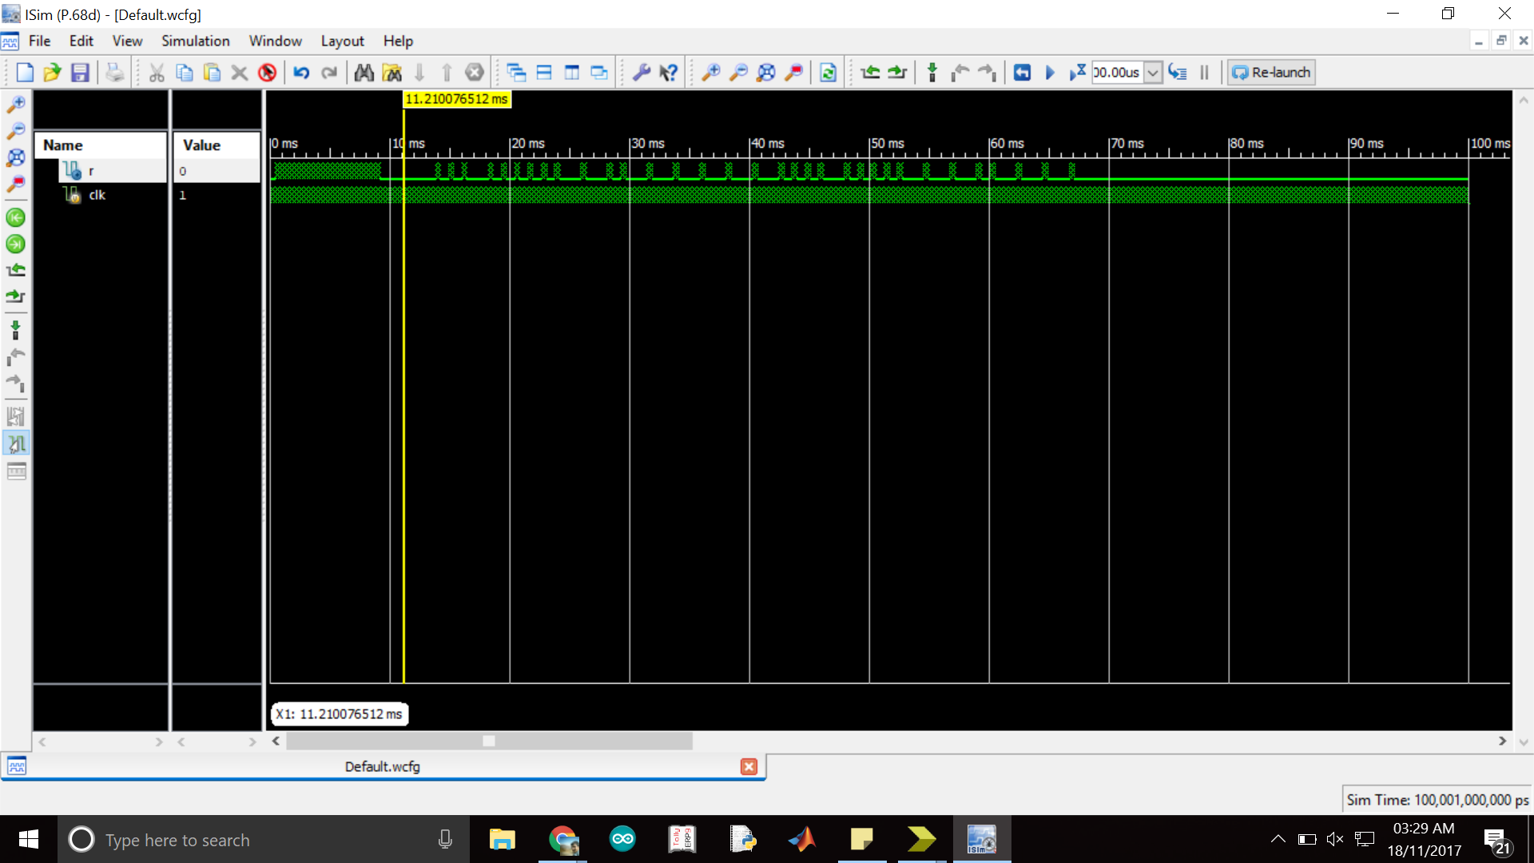

This is our Verilog output

# **CONCLUSION**

We were able to make a bluetooth controlled smart T.V. Remote for L.G. T.V. By sending signals through bluetooth on fpga board by implementing nec protocol . We would like to carry forward this work and would like to implement universal remote.

1. **ACKNOWLEDGMENT**

We would like to thank Joycee Mekie, Electronics lab staff, Sarathchandran and Joydeep for their constant source of motivation and support for helping us to successfully complete the project..

1. **REFERENCES**

<https://exploreembedded.com/wiki/NEC_IR_Remote_Control_Interface_with_8051>

<http://www.circuitvalley.com/2013/09/nec-protocol-ir-infrared-remote-control.html>

<https://wiki.eprolabs.com/index.php?title=Bluetooth_Module_HC-05>

1.